**PROJECT SUMMARY:** The technology for imaging neural activity in the rodent cortex has advanced dramatically. Using two-photon excited fluorescence microscopy and genetically encoded calcium indicators it is possible to record from many hundreds of neurons simultaneously in the cortex of awake, head-fixed mice during behavioral tasks. While cortical imaging is advancing rapidly, capabilities in other areas of the central nervous system remain underdeveloped. Neurons in the spinal cord play a critical role in coordinating rhythmic movements, such as walking and running. Because of its dense myelination, the white matter on the dorsal surface of the spinal cord is highly optically scattering and prevents imaging of underlying cells using two photon imaging. The goal of this grant is to develop tools that will overcome these limitations and enable imaging of neural activity in the spinal cord of mice that are awake and spine-fixed under a microscope while moving on a treadmill. These tools will enable studies that directly correlated patterns of neural activity in the spinal cord with limb movement and locomotor speed. These circuits have been studied primarily in reduced preparations, such as explanted neonatal spinal cords. The approach here would enable neural activity to be recorded in intact, adult animals that are awake and moving. In Aim 1, a treadmill that enables a mouse to be spine-fixed under the microscope will be developed. A long-term implantable spinal cord imaging chamber provides optical access to the spinal cord and enables the mouse to be spine-fixed on top of the treadmill. Detailed tracking of limb kinematics and locomotor speed will also be implemented. Care will be taken to optimize the setup so spine-fixed mice move with as normal a gait as possible. In order to image through the highly-scattering white matter, longer wavelength light and higher order nonlinear excitation of fluorescent labels is necessary. Using 1.3-µm wavelength excitation pulses, green emitting fluorescent molecules can be three-photon excited. Similarly, 1.7-µm light is suitable for three-photon excitation of red emitting fluorescent species. In Aim 2, the capabilities and limits of three-photon imaging in the spinal cord of mice will be explored. In preliminary data, cell structure and neural activity could be imaged as deep as 0.5 mm beneath the dorsal surface of the spinal cord, with even greater imaging depth likely achievable. The resolution, signal to noise, and depth penetration capabilities will be determined for each excitation wavelength and for both structural fluorescent labels and calcium indicators. In the final Aim, this new approach will be used to image the patterns of neural activity in a genetically-defined class of interneurons that are involved in locomotion. In particular, the activity of Chx10-expressing neurons will be correlated with limb movement and the hypothesis that the set of active cells changes with locomotion speed will be directly tested. Taken together, this project will establish the capability to image patterns of neural activity in the spinal cord of awake, behaving mice and then demonstrate the utility of this approach in a study of one class of spinal cord interneurons.

**RELEVANCE**

Neurons in the spinal cord form circuits that control rhythmic motions such as walking and running. Despite the importance of understanding how these circuits work and how they fail after spinal cord injury or in diseases such as amyotrophic lateral sclerosis, there is no existing approach to directly measure the patterns of activity across a large ensemble of spinal cord neurons in awake, moving animals. Here, we propose to develop imaging approaches that will enable neural activity to be directly visualized in the spinal cord of awake mice that are spine fixed under the microscope and able to move on a treadmill.

**SPECIFIC AIMS**

Recent work on cell-resolved optical imaging of neural activity in the brain of awake, behaving animals has opened the door to decoding the neural networks that are responsible for integrating sensory information, initiating motion, and performing navigation 1. Such approaches will clearly be a cornerstone of the recently-announced BRAIN initiative. This work was enabled by a combination of three technologies. First, the development of chronic cranial window surgical preparations, head-restraint devices, and training protocols allowed mice to be head-fixed under a microscope while awake, calm, and performing simple tasks 2. Second, fluorescent genetically encoded calcium indicators (GECIs), such as GCaMP, enabled long-term, high signal-to-noise, fluorescence based imaging of neural activity in these animals 3,4. Third, the use of two-photon excited fluorescence (2PEF) imaging to overcome the limitations of optical scattering enabled researchers to peer deep into the intact brain of mice with sub-cellular spatial resolution 5,6. This suite of tools has made experiments to directly probe patterns of neural activity across hundreds, or more, of individual neurons in the cortex of awake, behaving mice possible 7. There are significant opportunities if the capability to image neural activity in the spinal cord of awake-behaving mice could similarly be developed. For example, it would be interesting to study altered patterns of motoneuron activity in mouse models of amyotrophic lateral sclerosis. Or, recent work suggesting different classes of interneurons are recruited to control left-right limb alternation at different locomotion speeds could be directly verified by imaging the activity of these cells 8. There are significant challenges for cell-resolved imaging in the spinal cord of mice, however. First, while we recently described an implanted spinal cord imaging chamber that allows long-term optical access to the spinal cord 9,10, this chamber has not yet been adapted for use with an awake animal that is spine-fixed under the microscope. More critically, the white matter is on the dorsal surface of the spinal cord, and because it has a very short scattering length, even 2PEF imaging cannot penetrate it and visualize the neurons below. Here we propose to overcome these limitations and develop the capability to visualize cell-resolved neural activity in the spinal cord of mice. We will adapt our spinal cord imaging chamber for awake, spine-fixed imaging, and we will explore the utility of three-photon excited fluorescence (3PEF) imaging 11 to achieve the greater penetration depth we need to see through the white matter. Finally, we will use these new techniques to explore the patterns of activity in spinal interneurons during locomotion at different speeds. Taken together, **this work will first develop the capability to image neural activity in the spinal cord of awake mice moving on a treadmill and then demonstrate the utility of this approach by correlating patterns of activity in a genetically defined set of neurons in the spinal cord with hind limb movement.**

**Aim 1: Develop the capability to image the spinal cord in awake, behaving, spine-fixed mice**

*Hypothesis:* With appropriate training, mice will be able to walk and run on a custom treadmill while spine-fixed.

*Approach:* We have demonstrated awake, spine-fixed imaging using a rudimentary treadmill and the implanted spinal cord imaging chamber we developed 9. We propose to construct a drum-based treadmill and to optimize animal training protocols so that mice can walk and run while spine-fixed. We will perform high-resolution tracking of both hind limbs and then optimize the treadmill and mouse holding apparatus as well as the training protocol so that animals move as naturally as possible while held spine-fixed on the treadmill.

**Aim 2: Demonstrate three-photon excited fluorescence imaging of cell structure and neural function**

*Hypothesis:* 3PEF imaging will enable high-resolution imaging of cell structure and neural function deep into the spinal cord of mice.

*Approach:* Using a 3PEF microscope currently in the final stages of construction, we will quantify the depth penetration, spatial resolution, and signal to noise when imaging fluorescent labels and genetically encoded calcium indicators using both 1.3 and 1.7 µm excitation wavelengths. We focus on developing the capability to reliably record calcium transients in large ensembles of individual neurons using GECIs. We anticipate that residual axial motion artifact from breathing and locomotion will need to be corrected by adding fast translation of the microscope objective with a feedback loop.

**Aim 3: Correlate patterns of Chx10 interneuron activity in the spinal cord with locomotor behavior**

*Hypothesis:* The descending excitatory Chx10 positive interneurons will form a heterogeneous population in adult animals whose patterns of activity are tied to specific features of locomotion such as the flexor or extensor phases of limb movements or the speed of locomotion. Based on studies of axial circuits in zebrafish, we expect that the set of active neurons will shift with locomotor speed, with neurons in the population active during slow movements being silenced as those active during faster movements are recruited.

*Approach:* We use genetic strategies to target expression of GECIs to Chx10 positive neurons. We then image the patterns of activity of these neurons using 3PEF microscopy in awake, behaving mice while also quantifying the motion of both hind limbs as the mice move at different speeds on the treadmill.

**RESEARCH DESIGN**

**Significance**

*Imaging patterns of neural activity to understand the functional organization of spinal cord circuits.* Repairinglocomotor function after spinal injury or effectively treating motoneuron disease requires basic information about how the networks controlling movement in limbed vertebrates are organized normally, so the target for recovery is clear. Much of our knowledge of these circuits so far has come from seminal studies of neonatal mice which have identified neuronal classes important in locomotor networks based upon transcription factors that direct the differentiation of neuronal cell types in spinal cord 8,12,13,14. The major limitation of this work has been its focus on neonatal animals and isolated spinal cords, with “fictive” locomotion typically induced by application of drug cocktails. The new imaging approaches outlined here offer the unprecedented possibility of imaging the activity of classes of neurons in adult spinal cord during actual locomotion. As a demonstration of the power of this approach, we conduct studies of one class of these neurons, the Chx10 (V2a) cells, which are important for the excitatory drive during locomotion. We will explore the diversity of their activity patterns during locomotion in relation to limb kinematics and locomotor speed and test the idea arising from more simple species (larval zebrafish) that the active spinal interneuronal populations shift with changes in the speed of movement 15,16. While the biological problem we propose to address is necessarily an early application of the technology we will develop, it will still be the first study to reveal how cells from a known neuronal class (the Chx10 cells) are recruited during actual locomotion in adult animals.

*Deep imaging of cellular dynamics in the spinal cord will enable novel studies of disease.* While not the focus of this proposal, the imaging techniques we develop will be of great value in studying cell interactions in animal models of spinal cord diseases, such as spinal cord injury (SCI). One persistent challenge in the development of treatments for SCI has been an inability to study disease dynamics and therapy response by direct imaging of damaged axons and other cells in live animal models. The results of experiments that use conventional methods such as post-mortem histology or behavioral assays are often difficult to interpret. Functional recovery can be ambiguous, as significant recovery is possible in the absence of axonal regeneration in small, quadruped animals, such as mice. It is also difficult to distinguish regenerating axons from injured ones using histological studies that allow visualization at only a single time point. Longitudinal imaging of cell behavior after SCI would avoid these problems and provide a new approach to elucidating injury mechanisms and testing therapeutic strategies. Here, we propose to build an instrument that enables cell-resolved imaging of neural structure and function deep into the spinal cord of awake, behaving mice over long times. Such an instrument would allow direct imaging of axon degeneration and sprouting, changes in myelination and blood flow, astrocyte and microglia activation and scar formation, and changes in neural activity all to be quantified over minutes to months after SCI. In addition, imaging of neural activity could be done in mice while they perform tasks, making it possible to directly assess and correlate changes in neural activity or other cellular behaviors with behavioral change over time, all within an individual animal. While the initial demonstration experiments we propose here focus on the recruitment patterns of spinal cord interneurons during locomotion, it is clear that the imaging capabilities we will develop would enable novel, high-impact studies of SCI.

**Innovation**

*Imaging patterns of neural activity in the spinal cord of awake, locomoting mice.* No one has been able to image the activity of groups of spinal interneurons in adult, locomoting animals. We aim to develop the capability to directly monitor patterns of activity in neurons in the grey matter of the spinal cord in awake mice that are able to move while spine-fixed on a treadmill. Our ability to do this depends on innovations in spinal window development as well as our development of laser and microscope technologies for deeper imaging in highly scattering tissue. We have strong preliminary data indicating that our goal is achievable. This capability will provide a new window on the functionality of the central pattern generator (CPG) circuits that control rhythmic motor outputs, such as those associated with walking and running. Earlier work revealing activity of spinal-cord neurons involved in circuits for mammalian locomotion was technically limited to studies of explanted spinal cords from neonatal animals. Rhythms in CPGs were typically induced in isolated sections of spinal cord by drug cocktails, and the spinal cords were isolated from animals at an age when they are unable to support body weight and so could not actually walk or run. Our work breaks through previous technical barriers to allow for imaging of activity patterns in intact and locomoting adult mice. This capability opens the door to tests, in adult mice, of ideas about the function of spinal circuitry that have been developed based on neonatal work, including an exploration of how functional diversity might broaden in animals that can support their body and how movement at different speeds is accomplished by pools of interneurons. An understanding of this normal activity is a basis for assessing the changes in that activity after spinal injury or motoneuron disease and after treatments designed to promote recovery. The approaches we propose to develop are designed to eventually allow imaging of both the regeneration of axons and neuronal functional recovery at the cellular level repeatedly over time in a minimally invasive way. The goal of this grant is to develop the capability for robust and reliable imaging of neural activity in the spinal cord and to demonstrate the power of this approach by correlating activity in one population of spinal cord interneurons with hind limb kinematics.

*Exploring the capabilities and limits of three-photon excited fluorescence microscopy in the spinal cord.* Nonlinear microscopy has become the technique of choice for imaging with cellular resolution deep (~1 mm) into scattering tissue in live animals, including the central nervous system. Due to low phototoxicity, imaging over many hours at a time and over multiple sessions in animal models is possible and, coupled with cranial window methods, has enabled studies that have elucidated the cellular dynamics that underlie many normal and disease state physiological processes in the brain. In this imaging approach, a tightly-focused, short-duration laser pulse is scanned through the sample. Nonlinear optical interactions at the laser focus lead to the generation of new wavelengths and the intensity of these signals is recorded as a function of position to build an image. A wide variety of nonlinear optical effects can be used to form an image. Second and third harmonic generation provide intrinsic contrast to visualize molecules with no inversion symmetry (e.g. collagen 17) or to visualize bold optical interfaces (e.g. myelinated axons 18), respectively. Coherent anti-Stokes Raman scattering can image lipid deposits 19. Two-photon excited fluorescence, by far the most common nonlinear signal used for image contrast, enables sub-micrometer-resolved imaging of tissue components labeled with exogenous dyes or fluorescent proteins to depths of nearly a millimeter in cortical tissue.

For any nonlinear optical process, only laser photons that reach the focus unscattered can contribute to the nonlinear effect, so scattered excitation light does not degrade resolution or contrast (although the laser power must be increased to compensate for the loss of light). In turn, because the signal generation is limited to the laser focus, any signal photons that are detected can be used to reconstruct the image, regardless of their (scattered) path through the sample. These properties together give nonlinear microscopies a remarkable insensitivity to optical scattering. For deep nonlinear imaging, however, the laser power must be increased exponentially with depth to maintain the signal strength. At the maximal 2PEF imaging depth, the laser intensity at the sample surface approaches the intensity of the unscattered light reaching the focus. In this case, 2PEF is generated from a large volume of out-of-focus structures near the sample surface, producing a background that hides the 2PEF signal from the laser focus. This signal to background limit fundamentally prevents 2PEF imaging at depths of more than about 5 times the attenuation length (depends on absorption and scattering lengths) for the excitation light. For the cortex, this gives a depth approaching 1 mm for 800 nm excitation light, enough to visualize most of the cortex. For the spinal cord, however, where the highly-scattering white matter is on the dorsal surface, it is difficult to image more than ~150 µm deep 9.

The imaging depth of nonlinear microscopy can be improved by using higher-order nonlinear processes. By using a three-photon process to excite fluorescent dyes the signal to background limit is reached at a much deeper depth. In addition, to excite the same dye with three instead of two photons implies the use of a longer wavelength excitation source, and therefore an increased scattering length and further increases in the depth penetration. With longer wavelength excitation light in the near-infrared, it is critical to avoid wavelengths where there is strong absorption by water or other tissue components. We recently demonstrated 3PEF imaging of red fluorescent protein-labeled hippocampal neurons through the intact cortex and highly-scattering external capsule using 1.7 µm excitation light 11. Here, we explore two wavelengths for 3PEF imaging, 1.3 µm and 1.7 µm, both windows where water and tissue absorption are low enough to permit deep imaging with minimal sample heating. The 1.3 µm light will three-photon excite green emitting fluorescent molecules such as green fluorescent protein (GFP), FITC, and the GECI GCaMP6, while the 1.7 µm light will efficiently pump red fluorescent species such as RFP, Texas Red, and the GECI RCaMP. We will characterize the resolution, image contrast, and depth penetration for imaging multiple different fluorescent markers with each of these wavelengths in the spinal cord of mice. Our preliminary data indicates imaging depths of >0.5 mm are achievable, with the ability to resolve calcium transients from individual neurons expressing GECIs.

**Approach**

**Aim 1: Develop capability to image the spinal cord in awake, behaving, spine-fixed mice**

The goal of this aim is to design, build, and optimize a treadmill for spine-fixed mice that has the capability to quantify hind limb motion. A critical requirement for this system is that the normal limb kinematics are altered as little as possible for animals on the treadmill.

*Spinal chamber.* We plan to use the long-term implantable spinal cord imaging chamber we have already developed (Fig. 1) 9,10. This chamber allows optical access to the spinal cord for weeks to months. With careful surgery, there is no injury to the spinal cord beyond some mild microglia activation that subsides in a couple of weeks and the chamber does not restrict mouse locomotion, as assayed by multiple tests. When mounted under a microscope, the chamber holds the spine quite fixed and limits the movement artifacts associated with breathing to less than 5 µm and virtually eliminates heartbeat induced movement. To facilitate easy attachment of awake mice to the treadmill apparatus, we will modify the top plate of our design to enable quick release.

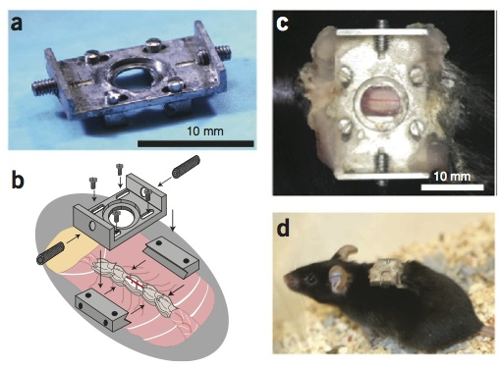 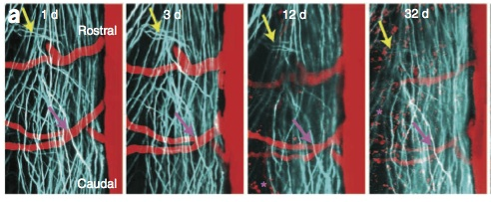

**Fig. 1. In vivo imaging in the murine spinal cord.** (left) Chamber for long-term in vivo optical imaging in spinal cord of a mouse. (right) Imaging of YFP-expressing axons (teal) and blood vessels labeled with an intravenous dye injection (red) in the spinal cord of a mouse over a month. Images from Ref. 9.

*Preliminary data on awake, spine-fixed mice.* Our lab has adopted the awake brain imaging approaches described in Dombeck, et al. 2, where head-fixed mice stand on a Styrofoam ball that is suspended on a cushion of flowing air. In an initial test of the possibility of spine-fixed mice standing and moving on a treadmill, we trained mice with implanted spinal cord imaging chambers to comfortably run on the floating ball, first without and then with spine fixation. While this worked more or less right away (Fig. 2), this test also revealed some opportunities to improve the design. First, for the studies proposed here, we do not need the mouse to be able to “turn” and can use a treadmill with just one axis of rotation. This will decrease any rotational stress on the implant chamber and spine. Second, we need to accommodate the normal movement of the mouse’s back up and down during each stride. This was less important with head-fixed animals, as there is plenty of flexibility in the neck. Finally, we will incorporate high-fidelity tracking of the movement of both hind limbs.

*Design of spine-fixed mouse treadmill.* We propose to use a rotating drum, which the mouse will stand on top of, for our treadmill. The drum will be about 20 cm in diameter so the mouse will run on a relatively flat surface. We will 3D print the drum from lightweight plastic so the weight of the drum is similar to that of the mouse. The drum will be mounted on a horizontal rod using roller bearings. With modest tuning of the friction at this junction, we will approximately match the force required to rotate the drum to that the mouse exerts when moving forward. This will give the right “feel” for movement. Because the mouse’s back moves up and down several millimeters during each stride, we will suspend the horizontal rod on springs with a stiffness chosen so the drum will move down a few millimeters under the force the mouse exerts with each step (about 50% of body weight 20). To prevent the drum from swinging forward and back on the springs, we will incorporate linear bearings that restrict the drum motion to up and down. To discourage the animal from turning, we will incorporate a small tunnel-like enclosure in front of the mouse. In initial tests on a disk-shaped treadmill, most mice seem to prefer to try to run into the tunnel and thus they stick with forward motion on the treadmill and do not try to turn. The treadmill will include brackets to hold the spinal cord chamber, which will be adjustable up/down, forward/backward, and rotatable along the pitch axis. This adjustability will allow us to tune the configuration for each mouse’s size, implant location, and apparent preferences. The pitch adjustment will be especially important if we implant the chamber more rostral or caudal from thoracic vertebrae 12 (T12), which is at the peak of the curve of the mouse’s back. Mice prefer to run slightly uphill rather than downhill on the ball treadmill, so we will likely find that mice prefer to be placed slightly back from the top of the drum and angled modestly upward.

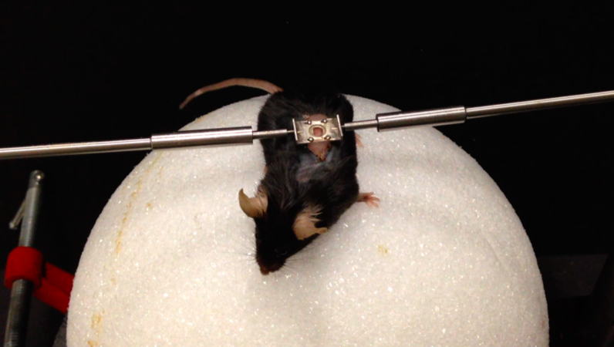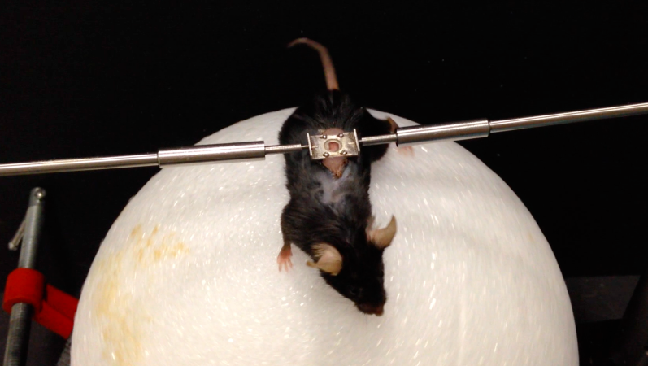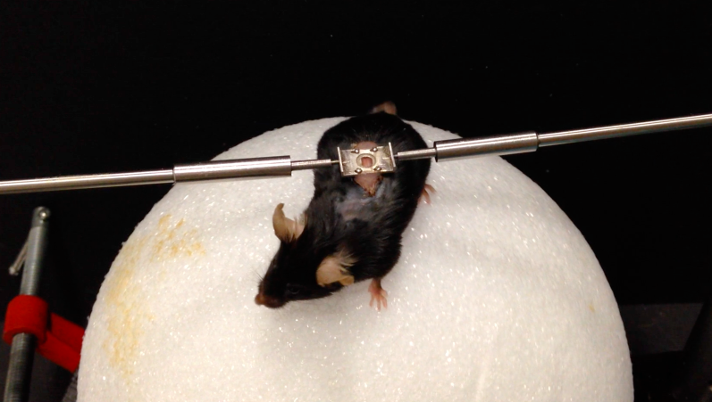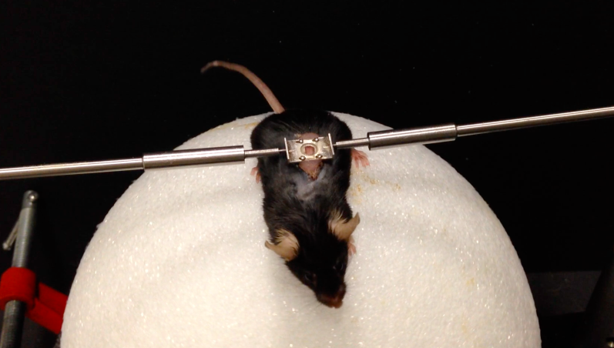

**Fig. 2. Spine-fixed mouse on treadmill.** Images at different times of a mouse fixed by the spinal chamber implant and standing on a Styrofoam ball floating on a cushion of air.

*Limb tracking system.* We will implement a robust system of limb tracking. Two mirrors will be mounted at 45 degrees on either side of the mouse and angled so a single camera imaging from the caudal end of the mouse will be able to see both hind limbs from the side, as well as image the laterality of limb placement from behind. We will use infrared illumination and paint small spots of infrared high reflectivity paint onto the side of the toe, ankle, knee, and hip of the mouse’s hind limbs. This system will enable simultaneous imaging of both hind limbs. The high contrast of the infrared reflective paint will enable automated tracking software to quantify the time-dependent locations of the leg joints. This will facilitate very sensitive analysis of hind limb kinematics during low and high speed locomotion 21.

*Tuning to achieve minimally-altered gait while spine fixed.* We will measure gait patterns of several mice when running on the treadmill with and without spine fixation (lightly holding the mouse’s tail when not spine fixed to keep them on the treadmill). We will then empirically adjust the position and angle of the brackets holding the spinal cord chamber, the mass of the drum, the friction at the roller bearing, and the stiffness of the spring to try to achieve gait parameters for spine-fixed animals that most closely match animals freely moving on the treadmill. (Previous work showed that treadmill gaits are similar to open field gaits, although mice tend to take smaller strides on a treadmill 22.)

**Aim 2: Demonstrate three-photon excited fluorescence imaging of cell structure and neural function**

In this aim, we explore the utility and limits of 3PEF imaging of cell structure and neural calcium transients using both 1.3- and 1.7-µm wavelength excitation sources. Using a microscope in Xu’s lab, we have already gathered data indicating that neural activity can be recorded as deep as 0.5 mm into the spinal cord – more than deep enough to image activity in Chx10 interneurons. We are currently finishing construction of a microscope in the Schaffer/Nishimura lab that will have both higher laser power and improved fluorescence detection efficiency, likely enabling even deeper imaging.

*3PEF microscope design and construction.* We are current completing construction of a dedicated 3PEF microscope. This system utilizes our high-collection efficiency optical design for collection and detection of fluorescence (see Fig. 3 in Ref. 23), which will improve signal to noise by about a factor of two compared to the current system. The 1.7 µm source (Raman shifting of 1.5 µm light in a large mode area photonic crystal rod) is in place and being tested now. It should produce about 25% more optical power than the system we used for preliminary data. The 1.3 µm source has been ordered and will be delivered in August of this year. This laser will represent a huge improvement over the system we used for preliminary data, with more than twice the pulse energy at a higher repetition rate. Taken together, we expect the microscope we are constructing to achieve higher signal to noise and even deeper imaging than what is shown in preliminary data, below.

We propose to make two critical modifications to this system for the proposed studies. First, we plan to add the capability to tip the microscope so that the imaging plane is not parallel to the floor. This will be an important degree of freedom that will allow us to set the angle of the imaging chamber on the treadmill to be optimal for the mouse and then tip the microscope to image at that angle. If we need to position the imaging chamber over lumbar vertebrae, on the caudal slope of the mouse’s back curve, then this tipping capability will be essential. We will design the system so there is minimal misalignment of the excitation beams as the microscope is tilted. Second, we will add a fast piezoelectric z-axis microscope objective scanner. In our preliminary 3PEF imaging data and in previous 2PEF imaging in the spinal cord, we noted that mouse breathing still led to up to 5 µm of axial motion of the spinal cord. The capability to rapidly move the microscope objective will enable us to compensate for this motion artifact as well as any axial motion of the spinal cord during awake locomotion on the treadmill. To provide feedback to keep the objective “locked” in focus, we follow the approach of Laffray, et al. 24. Briefly, we will introduce a small laser beam off axis in the back aperture of the objective. Some of that light reflects off the spinal cord surface and returns through the objective, again off-axis. We will pick off that reflected light and send it to a quadrature photodetector. The error signal from the quadrature detector will drive a feedback loop that moves the objective. With this system, we will have the capability to move the objective over small distances (~10 µm) with a bandwidth of ~100 Hz, more than enough to compensate for breathing and locomotion induced axial focus shifts. We have also noted small (< 2 µm) lateral shifts in the image due to breathing and expect similar shifts during locomotion. These last remaining motion artifacts will be removed using standard image alignment algorithms in the post-processing of the image data.

*Testing the capabilities and limits of 3PEF imaging in the spinal cord.* We begin by imaging anesthetized animals that express fluorescent proteins in specific cell types and/or that have structures of interest labeled with an exogenous fluorescent dye. For both 1.3 and 1.7 µm excitation light, we will take deep image stacks and determine the resolution (by measuring the width of fine features, such as dendritic spines or microglial processes), the signal to background ratio, and the signal to noise ratio in the image as a function of depth into the spinal cord. We will also quantitatively assess the effectiveness of the piezoelectric system to compensate for axial motion artifacts. The 1.3-µm excitation light is appropriate for three photon excitation of green emitting fluorescent molecules, so we will focus primarily on imaging cells labeled with GFP. The Schaffer lab currently has several lines of mice expressing GFP, including mice with all microglia labeled and mice with a subset of spinal neurons labeled. The 1.7-µm source will excite yellow to red emitting fluorescent molecules. Here, we will use mice expressing YFP or RFP in subsets of spinal neurons as well as image blood vessels labeled with an intravenous injection of Texas Red-dextran. Fig. 3 shows imaging of blood vessels labeled in this way as well as the THG signal from myelinated axons taken in a live mouse. This particular image stack was actually acquired in an awake animal that was standing on the spherical treadmill. This preliminary image demonstrates imaging of the vasculature to a depth of 0.5 mm. The proposed experiments will reveal the depth limits and resolution of 3PEF imaging and will showcase the wide variety of cell types that can be visualized and physiological measures (e.g. measurements of blood flow in individual vessels 25) that can be obtained.

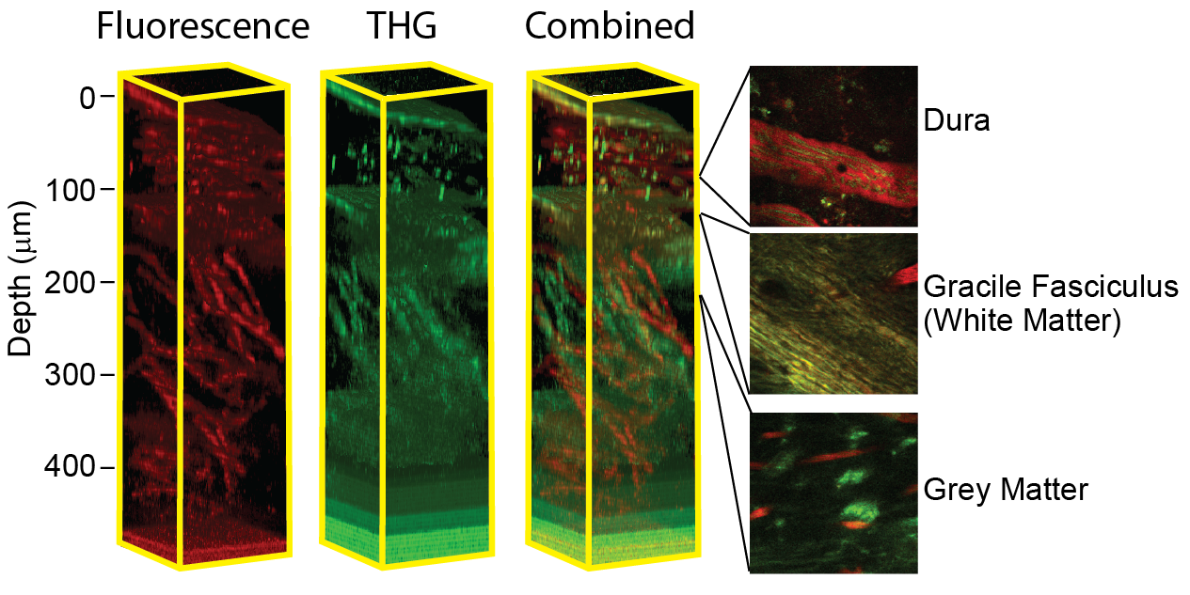

**Fig. 3. In vivo imaging of mouse spinal cord.** Vasculature (red) and myelinated axons (green) in the spinal cord of an awake mouse imaged by 3PEF and THG microscopy using 1.7 µm excitation light.

To image neural activity, we will focus on the use of GECIs. We use two different strategies to express these calcium reporters in neurons. First, we use adeno-associated virus (AAV) vectors. The AAV vector is injected through a micropipette into the spinal cord during the implantation of the imaging chamber and we observe robust neural expression within two weeks. Second, we utilize transgenic animals expressing GECIs. In initial experiments with AAV driven expression of GCaMP6, we observed neural activity in neurons in the dorsolateral horn of the spinal cord at a depth of ~250 µm beneath the surface in an anesthetized mouse. As it is a green-emitting fluorescent molecule, GCaMP was pumped with the 1.3-µm excitation source. There are sensory neurons in this part of the spinal cord and we observed increased neural activity when the ipsilateral hindpaw was pinched (Fig. 4). More recently, we have obtained a transgenic mouse with the GCaMP6 gene preceded by a stop codon surrounded by loxP sites. When crossed with a mouse that expressed Cre recombinase in neurons, we similarly observed stimulus-induced calcium transients in dorsolateral spinal cord neurons. Using an AAV vector to drive expression of a red variant GECI called RCaMP 26, we observed spontaneous neural activity in neurons a full 0.5 mm beneath the spinal cord surface (Fig. 5). We propose to follow up on these preliminary experiments with careful characterization of our ability to monitor calcium transients in spinal cord neurons. We will examine sensory areas and establish that we can observe stimulus-locked activity. We will explore how deep we can image and still have sufficient signal to noise to resolve calcium spikes (with both 1.3 and 1.7 µm excitation using GCaMP and RCaMP, respectively). We will image neurons in awake mice on our treadmill and determine if any neural activity patterns are correlated to hind limb movements. We will further perform the same imaging on mice expressing either GFP or RFP in similar cells to quantify the noise impact of any remaining motion artifact.

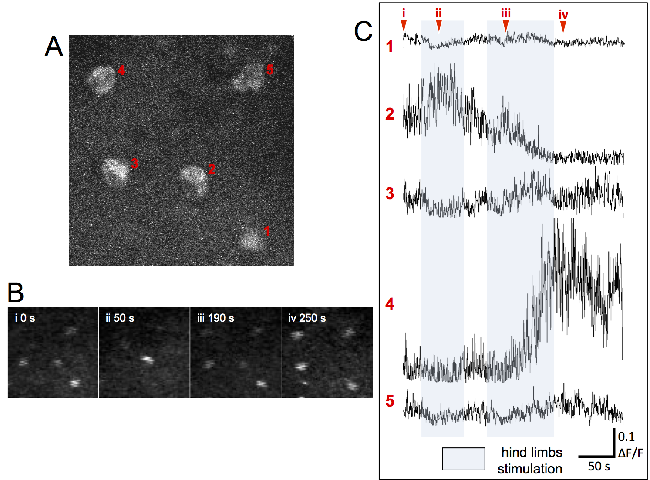

**Fig. 4. In vivo imaging of neural activity in the spinal cord of mice. (A)** 3PEF imaging of GCaMP-expressing neurons (driven by AAV) in the dorsolateral spinal cord. **(B)** Images of these neurons over time, showing increases in brightness associated with increased calcium concentration. **(C)** Normalized change in fluorescence as a function of time for the five neurons indicated in panel A. The Roman numerals at the top indicate the times of the image frames in B. The light-blue shaded regions indicate times of a manually-applied hindpaw stimulus. Neural activity, as reflected by increased calcium concentration, increases dramatically in cell 2 and 4 in response to the stimulation.

**Aim 3: Correlate patterns of Chx10 interneuron activity in the spinal cord with locomotor behavior**

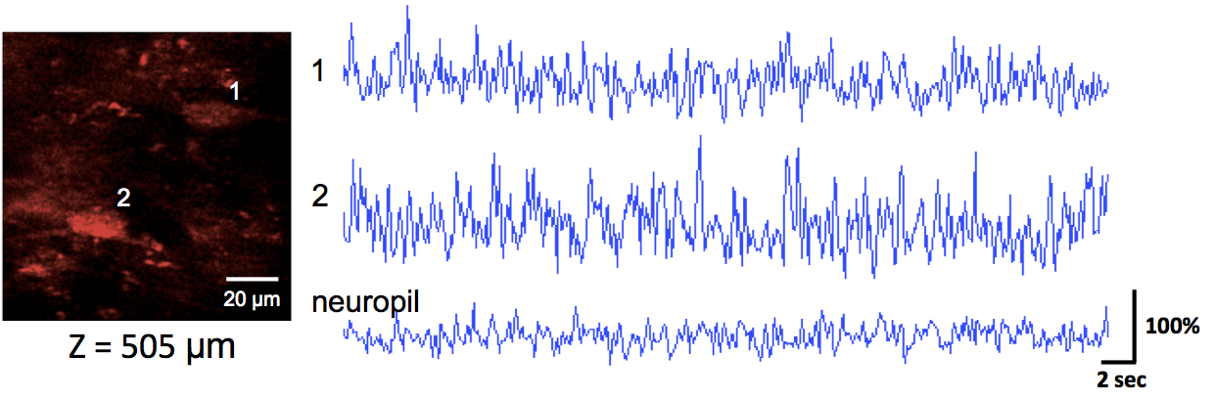

**Fig. 5. Imaging spontaneous neural activity using RCaMP and 1.7-µm pulses.**

In this aim, we demonstrate the power of these imaging capabilities by exploring the patterns of activity of a genetically-defined set of interneurons known to play an important role in locomotor behavior. We further test the hypothesis that there is a shift in the set of neurons that are active with changing locomotor speeds. Chx10 neurons will be labeled by crossing a mouse expressing Cre recombinase under the Chx10 promotor (e.g. stock # 005105 from Jax Labs) to a mouse with a floxed-stop GECI 14. This will lead to sustained expression of the calcium indicator in the Chx10 cells to allow for activity imaging in the adults. The most challenging aspect of this work is being able to image deep enough to see the neurons involved in the coordination of movement. We have shown we can image activity with RCaMP to 0.5 mm beneath the dorsal surface of the spinal cord (Fig 5). This depth will give us access to the Chx10 cells, which form one of the most superficial of the motor related interneuron classes. We will likely need to create a flox-stopped RCaMP mouse, which can be accomplished for ~$3k in ~2 months at Cornell’s state-of-the-art vertebrate genomics center. Our scope experimentally in this aim is necessarily modest, as much of this two-year proposal is focused on perfecting these novel imaging techniques to set the stage for future larger efforts. We plan to collect calcium imaging data from populations of Chx10 neurons synchronized with data on limb movement patterns and locomotor speed. We will be imaging initially near T12 because the spinal cord is thinner there, and it is adjacent to the hindlimb enlargement. However, it is not directly in the limb enlargement, which is a limitation. As we gain the capability to image deeper (we are not at the limit yet!), we will move the chamber back to L2/L3, directly over the hindlimb enlargement and repeat the experiments. From these data, we will determine which Chx10 neurons are activated during different phases of the locomotor cycle and how their patterns of activity change as the animal moves at different speeds. We will use the circular statistics now common in locomotor studies to look at the phase relationships between the neuronal calcium responses and the limb and axial movement patterns 27,8. With this data, we can attack two first level questions: How much heterogeneity exists in the firing patterns of the Chx10 neurons in the adult animal; and, Are there switches in the active interneurons as animals change the speed of movement? We know that there is structural heterogeneity in Chx10 populations in the adult based upon anatomical studies 28, but there has been no way to obtain the functional data during locomotion until now. Here we will observe patterns of activation of the neurons in relation to limb kinetics. We are particularly interested in what functional groupings exist and how those compare to the neonatal data. Neonatal animals have flexor and extensor subsets in the Chx10 population 29,30 31. We expect to see those in adults as well, but there is likely to be even greater specialization of cell types in the adult. Are there neurons that are active in association with particular features of limb kinematics such as movements about particular joints? Are there neurons that change their activity timing as interlimb coordination/timing changes? Finally, we know from studies of axial motor behaviors in zebrafish that the set of active Chx10 neurons changes with movement speed 15. Does this also happen in mice? Genetic perturbation of the Chx10 populations in mice can alter movement at high speeds, while preserving those at low speeds, suggesting a possible speed related organization 13. For this question, the problem of imaging near but not in the limb enlargement could be an asset as the fish data are from axial interneurons and at the T12 location we expect a mix of axial and limb related interneurons in mice.

**REFERENCES CITED**

1 Hamel, E. J., Grewe, B. F., Parker, J. G. & Schnitzer, M. J. Cellular level brain imaging in behaving mammals: an engineering approach. *Neuron* **86**, 140-159, doi:10.1016/j.neuron.2015.03.055 (2015).

2 Dombeck, D. A., Khabbaz, A. N., Collman, F., Adelman, T. L. & Tank, D. W. Imaging large-scale neural activity with cellular resolution in awake, mobile mice. *Neuron* **56**, 43-57, doi:10.1016/j.neuron.2007.08.003 (2007).

3 Broussard, G. J., Liang, R. & Tian, L. Monitoring activity in neural circuits with genetically encoded indicators. *Front Mol Neurosci* **7**, 97, doi:10.3389/fnmol.2014.00097 (2014).

4 Nakai, J., Ohkura, M. & Imoto, K. A high signal-to-noise Ca(2+) probe composed of a single green fluorescent protein. *Nat Biotechnol* **19**, 137-141, doi:10.1038/84397 (2001).

5 Denk, W., Strickler, J. H. & Webb, W. W. Two-photon laser scanning fluorescence microscopy. *Science* **248**, 73-76 (1990).

6 Zipfel, W. R., Williams, R. M. & Webb, W. W. Nonlinear magic: multiphoton microscopy in the biosciences. *Nat Biotechnol* **21**, 1369-1377, doi:10.1038/nbt899 (2003).

7 Dombeck, D. A., Graziano, M. S. & Tank, D. W. Functional clustering of neurons in motor cortex determined by cellular resolution imaging in awake behaving mice. *J Neurosci* **29**, 13751-13760, doi:10.1523/JNEUROSCI.2985-09.2009 (2009).

8 Talpalar, A. E. *et al.* Dual-mode operation of neuronal networks involved in left-right alternation. *Nature* **500**, 85-88, doi:10.1038/nature12286 (2013).

9 Farrar, M. J. *et al.* Chronic in vivo imaging in the mouse spinal cord using an implanted chamber. *Nat Methods* **9**, 297-302, doi:10.1038/nmeth.1856 (2012).

10 Farrar, M. J. & Schaffer, C. B. A procedure for implanting a spinal chamber for longitudinal in vivo imaging of the mouse spinal cord. *J Vis Exp*, doi:10.3791/52196 (2014).

11 Horton, N. G. *et al.* three-photon microscopy of subcortical structures within an intact mouse brain. *Nat Photonics* **7**, doi:10.1038/nphoton.2012.336 (2013).

12 Shevtsova, N. A. *et al.* Organization of left-right coordination of neuronal activity in the mammalian spinal cord: Insights from computational modelling. *J Physiol* **593**, 2403-2426, doi:10.1113/JP270121 (2015).

13 Crone, S. A., Zhong, G., Harris-Warrick, R. & Sharma, K. In mice lacking V2a interneurons, gait depends on speed of locomotion. *J Neurosci* **29**, 7098-7109, doi:10.1523/JNEUROSCI.1206-09.2009 (2009).

14 Crone, S. A. *et al.* Genetic ablation of V2a ipsilateral interneurons disrupts left-right locomotor coordination in mammalian spinal cord. *Neuron* **60**, 70-83, doi:S0896-6273(08)00677-6 [pii] 10.1016/j.neuron.2008.08.009 (2008).

15 McLean, D. L., Masino, M. A., Koh, I. Y., Lindquist, W. B. & Fetcho, J. R. Continuous shifts in the active set of spinal interneurons during changes in locomotor speed. *Nat Neurosci* **11**, 1419-1429 (2008).

16 McLean, D. L., Fan, J., Higashijima, S., Hale, M. E. & Fetcho, J. R. A topographic map of recruitment in spinal cord. *Nature* **446**, 71-75, doi:nature05588 [pii] 10.1038/nature05588 (2007).

17 Williams, R. M., Zipfel, W. R. & Webb, W. W. Interpreting second-harmonic generation images of collagen I fibrils. *Biophys J* **88**, 1377-1386, doi:10.1529/biophysj.104.047308 (2005).

18 Farrar, M. J., Wise, F. W., Fetcho, J. R. & Schaffer, C. B. In vivo imaging of myelin in the vertebrate central nervous system using third harmonic generation microscopy. *Biophys J* **100**, 1362-1371, doi:10.1016/j.bpj.2011.01.031 (2011).

19 Evans, C. L. & Xie, X. S. Coherent anti-stokes Raman scattering microscopy: chemical imaging for biology and medicine. *Annu Rev Anal Chem (Palo Alto Calif)* **1**, 883-909, doi:10.1146/annurev.anchem.1.031207.112754 (2008).

20 Fowler, S. C., Miller, B. R., Gaither, T. W., Johnson, M. A. & Rebec, G. V. Force-plate quantification of progressive behavioral deficits in the R6/2 mouse model of Huntington's disease. *Behav Brain Res* **202**, 130-137, doi:10.1016/j.bbr.2009.03.022 (2009).

21 Webb, A. A., Kerr, B., Neville, T., Ngan, S. & Assem, H. Kinematics and ground reaction force determination: a demonstration quantifying locomotor abilities of young adult, middle-aged, and geriatric rats. *J Vis Exp*, doi:10.3791/2138 (2011).

22 Herbin, M., Hackert, R., Gasc, J. P. & Renous, S. Gait parameters of treadmill versus overground locomotion in mouse. *Behav Brain Res* **181**, 173-179, doi:10.1016/j.bbr.2007.04.001 (2007).

23 Tsai, P. S. *et al.* Ultra-large field-of-view two-photon microscopy. *Opt Express* **23**, 13833-13847, doi:10.1364/OE.23.013833 (2015).

24 Laffray, S. *et al.* Adaptive movement compensation for in vivo imaging of fast cellular dynamics within a moving tissue. *PLoS One* **6**, e19928, doi:10.1371/journal.pone.0019928 (2011).

25 Shih, A. Y. *et al.* Two-photon microscopy as a tool to study blood flow and neurovascular coupling in the rodent brain. *J Cereb Blood Flow Metab* **32**, 1277-1309, doi:10.1038/jcbfm.2011.196 (2012).

26 Akerboom, J. *et al.* Genetically encoded calcium indicators for multi-color neural activity imaging and combination with optogenetics. *Front Mol Neurosci* **6**, 2, doi:10.3389/fnmol.2013.00002 (2013).

27 Zhang, J. *et al.* V1 and v2b interneurons secure the alternating flexor-extensor motor activity mice require for limbed locomotion. *Neuron* **82**, 138-150, doi:10.1016/j.neuron.2014.02.013 (2014).

28 Al-Mosawie, A., Wilson, J. M. & Brownstone, R. M. Heterogeneity of V2-derived interneurons in the adult mouse spinal cord. *Eur J Neurosci* **26**, 3003-3015, doi:EJN5907 [pii] 10.1111/j.1460-9568.2007.05907.x (2007).

29 Dougherty, K. J. & Kiehn, O. Firing and cellular properties of V2a interneurons in the rodent spinal cord. *J Neurosci* **30**, 24-37, doi:10.1523/JNEUROSCI.4821-09.2010 (2010).

30 Dougherty, K. J. & Kiehn, O. Functional organization of V2a-related locomotor circuits in the rodent spinal cord. *Ann N Y Acad Sci* **1198**, 85-93, doi:10.1111/j.1749-6632.2010.05502.x (2010).

31 Zhong, G. *et al.* Electrophysiological characterization of V2a interneurons and their locomotor-related activity in the neonatal mouse spinal cord. *J Neurosci* **30**, 170-182, doi:10.1523/JNEUROSCI.4849-09.2010 (2010).